Tyler Johnson

CIS261

Professor Mark Stone

21 August 2022

Payroll - Week 5 Lab

GitHub: https://github.com/T8T3S/Payroll

Figure : Screenshot of code in Visual Studio

Figure 2: Screenshot of code in Visual Studio

Figure 3: Screenshot of code in Visual Studio

Figure 1: Screenshot of Employee Input and “all” output

Figure 1: Screenshot of no data returned and date selection instead of “all”.

Figure 4: Screenshot of payroll.txt file in Visual Studio

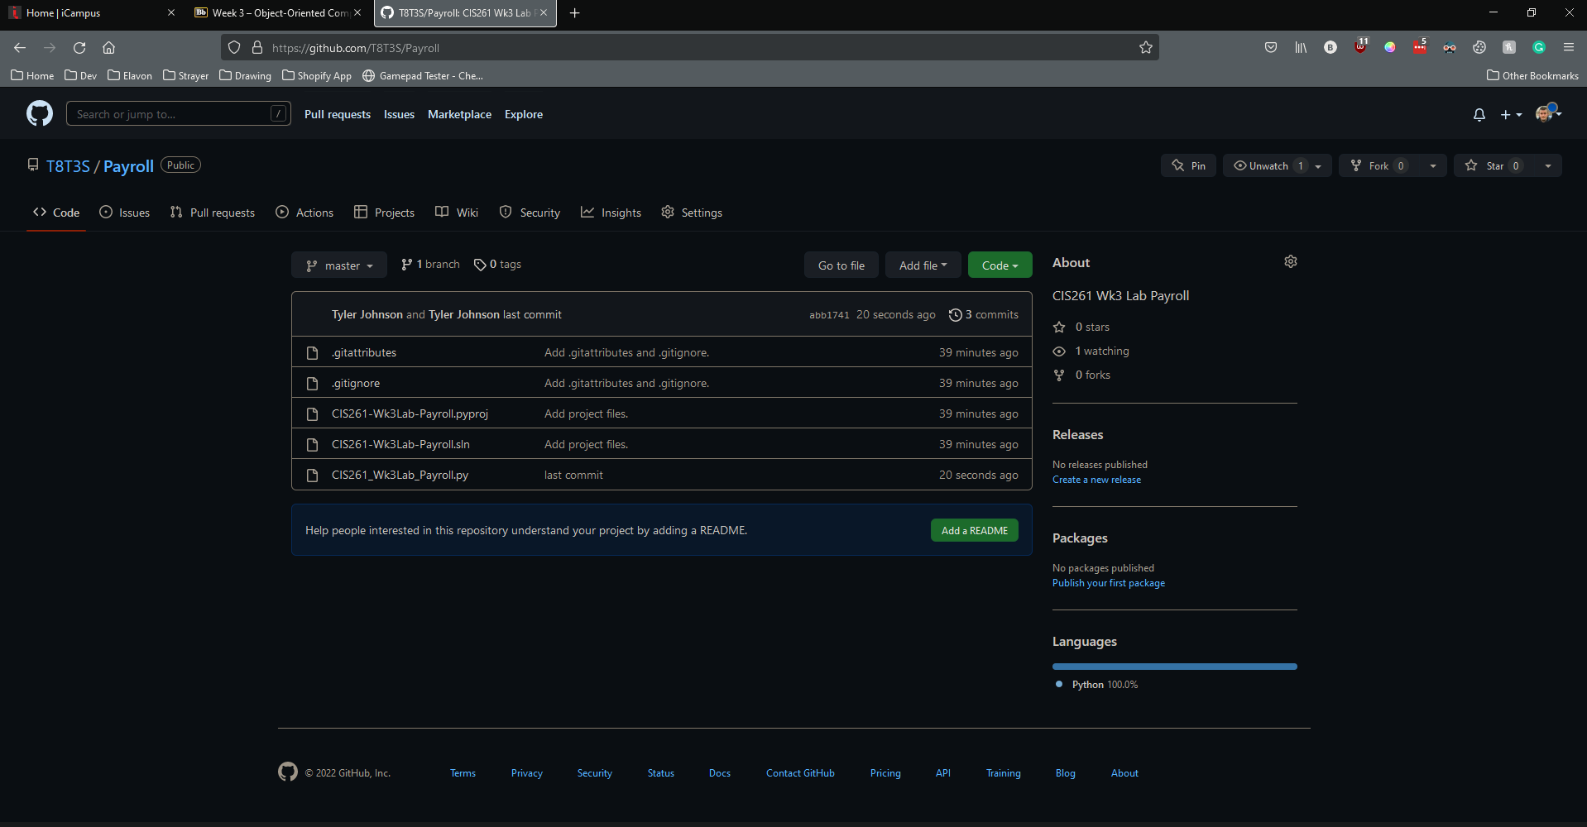

Figure : Screenshot of source code in GitHub

Figure : Screenshot of 5 employees entered with final output

One success I saw this lab was standardization of my function names when defined. Syntax is a very important part of coding and understanding the differences in syntax when reading code can help troubleshoot or debug one’s application. Also, I learned how effective functions can be as they help compartmentalize code and make the main function much cleaner.